Certainly! I'll transcribe the handwritten notes from the four images you provided.

**Transcribed Notes**

**Image 1 (Left Page)**

The image contains notes on **chage**, **user/group management commands**, and **chmod**.

**chage** : expiry info

* **-l** : Two password changes
* **-m** : minimum amount of time in between **maxday** : maximum day for password is valid.
* **-d days** : last change password in days.
* **-I** : Inactive days before lock
* **-W** : Warn days
* **-E** : expired

i) gpasswd ii) groupadd iii) groupdel

iv) groupmod

i) groupadd : -g, -0, -F

ii) gpasswd : -A w- username as grpname

w- username // Add user to group

gpasswd : [R] w- [d] [u] [gn]

newgrp -d remove delete

chmod g+x project // chmod 760

chmod u+rwx sem5

= to clean + = add - delete

**Image 1 & 4 (Right Page - RPM, DNS)**

The right side of the pages contains notes on **RPM** and **DNS**.

**RPM**

* **-q** : To check package is installed or not
* **-qa** : list of all install package
* **-qf /etc/passwd** : package own a file
* **-ql** : list of all files installed by package
* **-qi** : info about package
* **-qc** : configuration file about package
* **-qd** : documentation
* **-qR** : Libraries & Packages required.
* **-V** : package is installed correctly or not.

DNS

i) gedit /etc/hosts

check for 192.168.1.3 server.tyit.com

ii) gedit /etc/sysconfig/network-scripts/ifcfg-eth0

check for DNS1 = 192.168.1.3

iii) gedit /etc/sysconfig/network

check for NAME=HOSTSERV = server.tyit.com

iv) gedit /etc/resolv.conf

check for nameserver 192.168.1.3

**Image 2 (DNS, continued)**

This page continues with **DNS** setup steps.

v) **service network restart**

vi) cd /media

cd RHEL

cd Packages

rpm -ivh bind* (install bind)

vii) gedit /etc/named.conf

on line no 11 port 53 192.168.1.3 allow query any

on line no 17 allow query {any};};

viii) cd /etc

ls named*

gedit named.rfc1912.zones

@ copy zone 1 and paste at end of file with file "reversed.zones"

ix) cd /var/named

ls

cp named.localhost forward.zone

cp named.loopback reversed.zone

x) gedit forward.zone

@ server.tyit.com. root.tyit.com. { }

IN NS server.tyit.com.

server IN A 192.168.1.3

xi) gedit reversed.zone

@ server.tyit.com. root.tyit.com. { }

IN NS server.tyit.com.

IN ptr server.tyit.com.

xii) chgrp named forward.zone

chgrp named reversed.zone

ls -l

xiii) service named start

dig server.tyit.com

dig 192.168.1.3

**Image 3 (DHCP)**

The page contains notes on **DHCP** setup.

DHCP

i) network → IPv4 → method → Manual

IP address : 192.168.1.3

Netmask : 24

DNS : 192.168.1.1

ii) Install DHCP

cd /media

cd RHEL

cd Packages

rpm -ivh dhcp*

iii) **gedit /etc/dhcp/dhcpd.conf**

iv) gedit /etc/dhcp

cp /usr/share/doc/dhcp-4.1.1/dhcpd.conf.sample /etc/dhcp/dhcpd.conf

v) gedit /etc/dhcp/dhcpd.conf

change line no 32 : subnet 192.168.1.0 &

range in 192.168.1.15 192.168.1.30

vi) service dhcpd start

chkconfig dhcpd on

chkconfig --list dhcp

**Shut Down** **Open clone**

vii) network → IPv4 → method dhcp

ping 192.168.1.3

gedit /etc/sysconfig/network-scripts/ifcfg-eth0

check for BOOTPROTO = dhcp

service network restart

ifconfig

useradd gourpadd permission

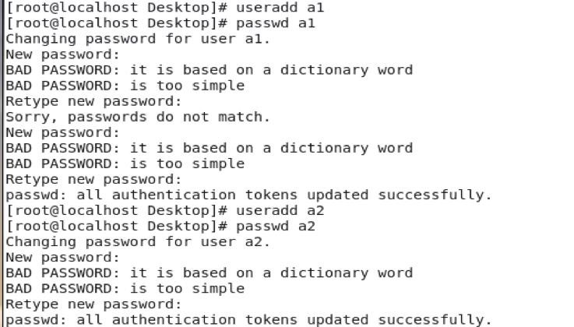

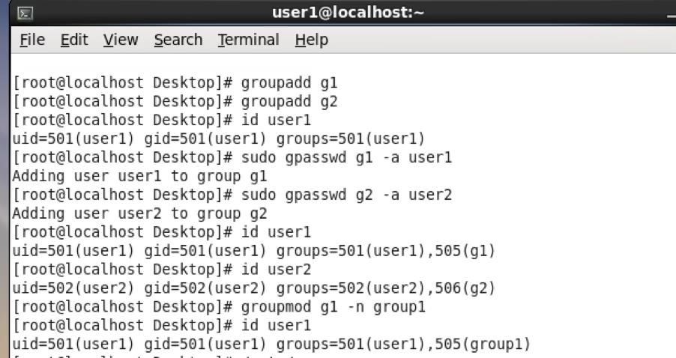

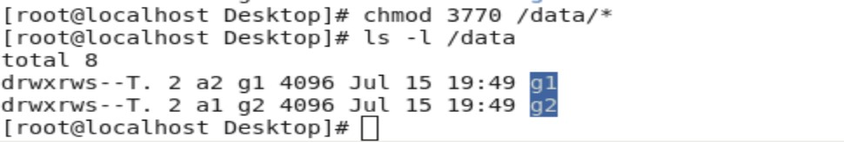

**Linux Command Notes with Examples**

**I. Password Expiry (chage)**

The **chage** command changes user password expiry information.

| Option | Description | Example |
| --- | --- | --- |
| **-l** | Lists the current password expiry information for a user. | chage -l alice |
| **-m** | Sets the **minimum** number of days between password changes. | chage -m 7 alice (User 'alice' must wait 7 days before changing their password again) |
| **-M** | Sets the **maximum** number of days the password is valid. | chage -M 90 alice (Password for 'alice' expires after 90 days) |
| **-d DAYS** | Sets the date of the **last password change** (by setting days since Jan 1, 1970). | chage -d 2025-09-01 alice |
| **-I** | Sets the number of **inactive days** before the account is locked after the password expires. | chage -I 30 alice |
| **-W** | Sets the number of **warning days** before the password expires. | chage -W 14 alice |
| **-E** | Sets the **account expiration date** (or set to -1 for no expiry). | chage -E 2025-12-31 alice |

Export to Sheets

**II. User/Group Management**

These commands are used for managing groups and user membership.

| Command | Description (from notes) | Example |
| --- | --- | --- |
| **groupadd** | Adds a new group. Options include **-g** (GID), **-r** (system group), **-F** (force). | groupadd engineers |
| **groupdel** | Deletes a group. | groupdel engineers |
| **groupmod** | Modifies group properties (e.g., name or GID). | groupmod -n developers engineers (Renames 'engineers' to 'developers') |
| **gpasswd** | Manages members and password for a group. | gpasswd -A alice developers (Sets 'alice' as the group **administrator**) |
| **gpasswd -a USER GROUP** | **Add user to group** (as noted). | gpasswd -a bob developers |
| **gpasswd -d USER GROUP** | **Remove** user from group (**delete** as noted). | gpasswd -d bob developers |
| **newgrp GROUP** | Changes the user's **effective primary group** (for the current session). | newgrp developers |

Export to Sheets

**III. File Permissions (chmod)**

The **chmod** command changes file mode bits (permissions).

| Notation | Description (from notes) | Example |
| --- | --- | --- |
| **Symbolic** | Changes permissions using **u** (user), **g** (group), **o** (others), **a** (all), and **+** (**add**), **-** (**delete**), **=** (**clean/set**). | chmod g+x project (Adds execute permission for the **g**roup on 'project'.) |
| **Symbolic** | Sets User permissions to read, write, and execute (**rwx**) for sem5. | chmod u=rwx sem5 |
| **Octal** | Sets permissions using numbers: 4=read, 2=write, 1=execute. **760** is **rwx** (user), **rw-** (group), **---** (others). | chmod 760 project |

Export to Sheets

**IV. Package Management (rpm)**

The **rpm** command is the Red Hat Package Manager utility.

| Option | Description (from notes) | Example |
| --- | --- | --- |
| **-q** | Checks if a **package is installed** or not. | rpm -q bash (Checks if the 'bash' package is installed) |
| **-qa** | Lists **all installed packages**. | rpm -qa |
| **-qf FILE** | Finds the package that **owns a file**. | rpm -qf /etc/passwd |
| **-ql PACKAGE** | Lists **all files** installed by a package. | rpm -ql httpd |
| **-qi PACKAGE** | Displays **info about a package**. | rpm -qi kernel |
| **-qc PACKAGE** | Lists **configuration files** about a package. | rpm -qc httpd |
| **-qd PACKAGE** | Lists **documentation** files about a package. | rpm -qd httpd |
| **-qR PACKAGE** | Lists **Libraries & Packages required** (dependencies). | rpm -qR firefox |
| **-V PACKAGE** | **Verifies** if a package is installed **correctly** or not. | rpm -V httpd |

I will transcribe the handwritten notes from the five images provided, grouping them by the main topic (DNS, NFS, and MAIL/Sendmail).

**Transcribed Notes**

**Image 3 & 5 (DNS Server Setup)**

The images detail the setup steps for a DNS server.

**3) DNS Server**

1. **ifconfig**
2. gedit /etc/sysconfig/network-scripts/ifcfg-eth0

(set the following parameter)

BOOTPROTO = none

DNS1 = 192.168.1.3

IPADDR = 192.168.1.3

NETMASK = 255.255.255.0

1. gedit /etc/hosts

Add this line: 192.168.1.3 server.tyit.com

1. gedit /etc/sysconfig/network

set the HOSTNAME = server.tyit.com

1. gedit /etc/resolv.conf

Add this search tyit.com

nameserver 192.168.1.3

1. **service network restart**
2. Packages) # rpm -q bind

rpm -ivh bind*

1. gedit /etc/named.conf

set line no 11: listen on port 53 {192.168.1.3};

comment line 12

set the line 17: allow-query {any;};

1. gedit /etc/named.rfc1912.zones

Make the changes after it have 5 zones

* 1. zone "tyit.com" IN {

type master;

file "forward.zone";

};

* 1. **AS Pt P5**
  2. **zone "0.0.127.in-addr.arpa" IN {**
  3. zone "1.168.192.in-addr.arpa" IN {

type master;

file "reverse.zone";

};

* 1. **AS Pt P5**

1. **cd /var/named**
2. **cp named.localhost forward.zone**
3. cp named.loopback reverse.zone

vim forward.zone

IN SOA server.tyit.com. root.server.tyit.com. (

10 ; serial

IN NS server.tyit.com

server IN A 192.168.1.3

1. vim reverse.zone

IN SOA server.tyit.com. root.server.tyit.com. (

10 ; serial

@ IN NS server.tyit.com

3 IN PTR server.tyit.com.

1. **named]# chgrp named forward.zone**
2. **# chgrp named reverse.zone**
3. **# service named start**
4. **# dig server.tyit.com**
5. **# dig -x 192.168.1.3**
6. **# nslookup server.tyit.com**
7. **# nslookup 192.168.1.3**

**Image 1 (NFS Setup)**

The image details the setup steps for an NFS (Network File System).

**1) NFS**

1. # rpm -qa | grep nfs

rpm -qa | grep rpc

Packages) # rpm -ivh nfs*

ifconfig eth0

cd /home/

home) # mkdir servernfs

cd servernfs

cat > newfile

hello tyit

(Ctrl + D to exit cat)

vp /etc/exports

/home/servernfs * (rw, sync)

service nfs restart

service iptables stop

service iptables status

server) # showmount -e 192.168.1.3

chmod -R 777 /home/servernfs/

cd /home

ls

home) # mkdir clientnfs

# mount -t nfs 192.168.1.3:/home/servernfs /home/clientnfs/

**ls /home/clientnfs**

**Image 2 & 4 (Mail/Sendmail Setup)**

The images detail the setup steps for a Mail/Sendmail server.

**4) MAIL server**

1. **# rpm -qa | grep sendmail**
2. Packages) # rpm -ivh progsmaii*

rpm -ivh sendmail*

1. vim /etc/mail/sendmail.mc

:se nu

comment line 116 with dnl

1. **m4 /etc/mail/sendmail.mc > /etc/mail/sendmail.cf**
2. **dig server.tyit.com**
3. vi /var/named/forward.zone

Add in last line:

IN MX 192.168.1.3

1. service sendmail restart

service sendmail stop

service sendmail restart

1. # useradd test

passwd test

1. mail test@server.tyit.com

subject: test mail

hi everyone

(Ctrl + D to send mail)

su - test

# mail

(View mail content)